Experiment-5

# **Task-1**

Plot the PSD for the given noisy ECG signal and design suitable filter for the same. 1.b. Acquire speech signal mixed with and without a back ground noise and apply a suitable filter then compare the filtered signal with the signal that is acquired without noise

# Code:

clc; clear all; close all;

noisy=load('ecg.txt');

figure(1)

subplot(3,1,1)

plot(noisy)

[b,a]=butter(10,[0.05 0.990],'stop');

clean=filter(b,a,noisy);

subplot(3,1,2)

plot(clean)

subplot(3,1,3)

pwelch(clean,'power');

# Output:

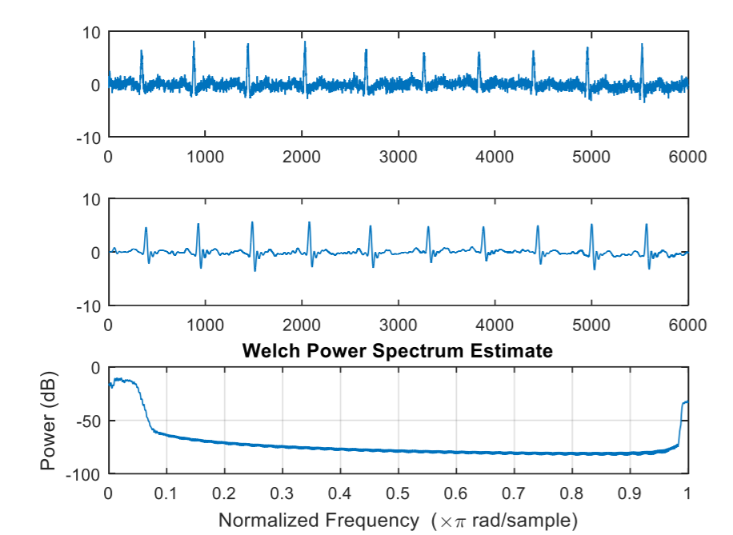

# **Task 2:**

Acquire speech signal mixed with and without a back ground noise and apply a suitable filter then compare the filtered signal with the signal that is acquired without noise.

# Code:

clc;clear all;close all;

[noisy,fs] = audioread('noisy.mp3');

clean = audioread('clean.mp3');

figure(1)

subplot(2,2,1)

plot(noisy)

axis([0 225000 -0.75 0.75]);

title('Input noisy audio file');

subplot (2,2,2)

plot(clean)

title('Input clean audio file');

axis([0 225000 -0.75 0.75]);

%FFT

N=length(noisy);

df = fs/N;

Fc=(-N/2:(N/2)-1)*df;

ft = fft(noisy,N)/N;

ft = fftshift(ft);

subplot(2,2,3)

plot(Fc,ft);

title('Freq Dist of Noisy file');

%Filtering

bf = 700/(fs/2);

sf = 12000/(fs/2);

[b,a]=butter(10,[bf sf],'bandPass');

filtered=filter(b,a,ft);

subplot(2,2,4)

plot(Fc,filtered)

title('Filtered result');

res = ifft(filtered);

% % % subplot(3,2,5)

% plot(fs,res);

%Play Result

p = audioplayer(filtered, fs);

p.play;

%Correlation

corr = xcorr(res,clean);

figure(2)

plot(Fc,corr);

title('Correlation between filtered and clean audio');

# Output:



